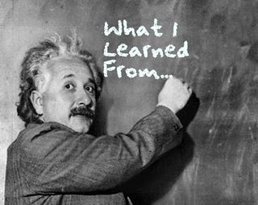
Theme Analysis
Name: ___________________
Novel: ____________________________________
The lesson/moral, “big idea” or theme of this book is…

What matters most to me is… (The part that will stick with me is…)

This is how the theme of this book relates to the real world and/or my life:

