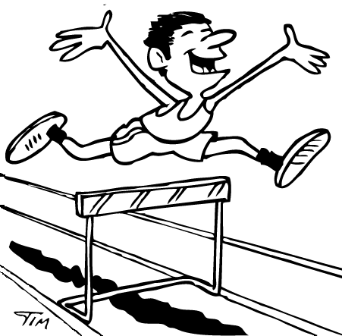
Jumping hurdles...

Character profiled on this page is _______________________
My novel is

Everyone has obstacles to overcome in life. Some have handicaps or disabilities; others have emotional pain; still others have a difficult home life. These hurdles can be difficult to deal with, but many people overcome them and enjoy a fulfilling life.
Have you (or has someone you know) ever dealt with an issue like this? Explain. If not, what would you do if you were in this situation? __________________________________________________
________________________________________________________________________________
________________________________________________________________________________
________________________________________________________________________________
________________________________________________________________________________
________________________________________________________________________________

How would you advise your character to deal with this hurdle?
_____________________________________________________
_____________________________________________________
_____________________________________________________
_____________________________________________________
_____________________________________________________

How is your character dealing with this hurdle? ______________
_____________________________________________________
_____________________________________________________
_____________________________________________________
_____________________________________________________
_____________________________________________________
What hurdle is your character facing? ______________________
_____________________________________________________
_____________________________________________________
_____________________________________________________
_____________________________________________________
_____________________________________________________

