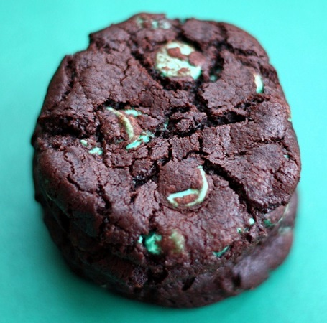
Chocolate Mint Chip Cookies

Ingredients:
1-1/4 cups flour
1 teaspoon baking powder
1/2 teaspoon salt
2/3 cup dutch-process cocoa-make sure to use dutch process for a rich/dark flavor
1/2 cup (1 stick) unsalted butter, cubed and room temp
1/2 cup white sugar
1/2 cup dark brown sugar
1-1/2 teaspoons vanilla
1/3 cup milk
1 bag of mint chips-I used Guittard

Directions:
- Preheat oven to 325 degrees F and line baking sheets with silicone baking mat or parchment paper.

- Whisk together flour, salt, baking powder and cocoa, and set aside.

- Beat the butter on medium-high until light and add sugars, creaming well. Add the vanilla and beat until smooth. Add the flour mixture in 2 batches, alternately with the milk in one batch, mixing well.

- Stir in the mint chips. Chill dough for at least 15 minutes. You can make the dough a few hours or 2 days before baking and it will be fine. Just wrap it up and keep in the fridge.

- Scoop the dough onto a parchment- or silpat-lined cookie sheet, press down on them slightly, and bake for 14-15 minutes…for a normal size cookie. Let the cookies cool completely on the cookie sheet, they will set up as they cool. Store in an air-tight container, they will stay fresh for a couple of days.

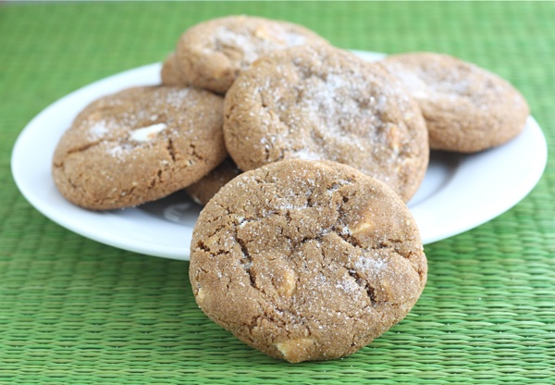
Soft Gingersnap Cookies with White Chocolate Chunks

Ingredients:
1 cup unsalted butter, at room temperature
1 cup granulated sugar
1/2 cup molasses
2 tablespoons canola oil
1 teaspoon vanilla extract
2 1/4 teaspoons baking soda
1 teaspoon salt
1 1/4 teaspoons cinnamon
1 1/4 teaspoons ground cloves
1 teaspoon ground ginger
2 large eggs
3 1/2 cups all-purpose flour
1 1/2 cups white chocolate chunks
1 cup granulated sugar-for coating cookie dough balls

Directions:
1. Preheat oven to 350°F. Line two large baking sheets with parchment papers or with a silicone baking mat. Set aside.
2. In the bowl of a stand mixer, cream together butter and sugar until smooth and creamy.
3. Beat in the molasses, canola oil, vanilla, baking soda, salt, and spices. Mix until well combined.
4. Add the eggs, one at a time, and beat until smooth. Slowly add in the flour. Next, stir in the white chocolate chunks.
5. Scoop the dough into balls and roll in granulated sugar. Place on lined baking sheets, about two inches apart. Bake for 10 minutes, the cookies will still be soft. Remove from oven and let cookies cool on the baking sheet for five minutes. Transfer to a wire rack and cool completely.

White Chocolate Peppermint M&M Cookies

Ingredients:
3 cups all-purpose Gold Medal flour (or just under 3 cups)
1/2 teaspoon salt
3/4 teaspoon baking soda
1 cup unsalted butter, at room temperature
1 cup light brown sugar
1/2 cup granulated sugar
2 large eggs
1 tablespoon vanilla extract
1 cup white chocolate chips
1/2 cup crushed candy canes
1 cup White Chocolate Peppermint M&M's

Directions:
1. Preheat oven to 350°F. Line a large baking sheet with a Silpat baking mat or parchment paper and set aside.
2. Combine flour, salt and baking soda in a medium bowl and set aside.
3. Cream butter and sugars together in a stand mixer fitted with the paddle attachment until combined. Add eggs and vanilla and beat until smooth. Slowly mix in the dry ingredients. Stir in the white chocolate chips, candy canes, and M&M's.
4. Drop heaping tablespoonfuls of dough on prepared baking sheets, about 2 inches apart. Bake for 10-12 minutes or until cookies are golden around the edges, but still soft in the center. Let the cookies cool on the baking sheet for 2 minutes. Transfer cookies to wire rack and cool completely.

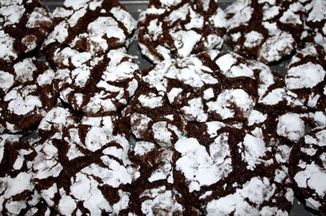
Chocolate Crinkle Cookies

Ingredients:
• 2 cups sifted all-purpose flour
• 2 teaspoons baking powder
• 1/2 teaspoon salt
• 1/4 cup canola oil
• 4 ounces 99% unsweetened chocolate, melted
• 2 cups granulated sugar
• 4 large eggs
• 2 teaspoons pure vanilla extract
• 1 cup confectioners’ sugar

Directions:
- Combine the flour, baking powder and salt. Set aside.

- In the bowl of a stand mixer fitted with the paddle attachment, combine the oil, chocolate and granulated sugar and blend on medium speed. With the mixer running, add the eggs, one at a time, followed by the vanilla, scraping the sides of the bowl as necessary. There may be some small clumps of sugar in the batter at this point.

- Add the dry ingredients and mix on low speed, stopping once to scrape down the sides. Mix until just incorporated, 2 to 3 minutes. The dough will be sticky.

- Gather the dough into a disk, wrap in plastic wrap and chill for at least 2 hours or overnight.

- Position the racks in the lower and upper thirds of the oven and preheat to 350 degrees F. Line 2 baking sheets with Silpats or parchment paper.

- Pour the confectioners’ sugar onto a plate or into a shallow bowl. Roll the dough into 1-inch balls, drop onto the sugar and roll each ball so that all sides are covered. Place 2 inches apart on the prepared sheets.

- Bake for 10 minutes for soft, chewy cookies, or 12 minutes for crisp cookies, rotating the pans halfway through baking. The cookies are done when the edges are set (but the tops still have a little give to them). Let cool completely on cooling racks. The cookies can be stored in an airtight container for 3 to 4 days.

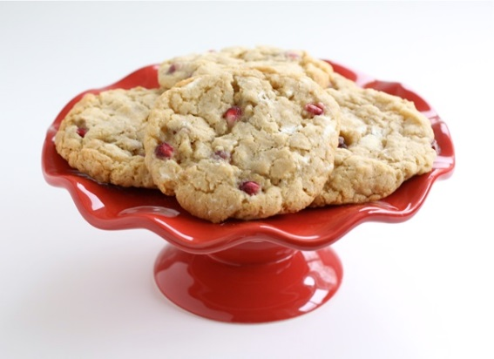
Cranberry White Chocolate Chunk Cookies

Ingredients:
1/2 cup unsalted butter, at room temperature
1/2 cup light brown sugar
1/2 cup white sugar
1 large egg
1 teaspoon vanilla extract
1 1/4 cup all purpose flour
1/2 teaspoon baking powder
1/2 teaspoon baking soda
1/4 teaspoon salt
1 cup old fashioned oats
1 cup white chocolate chunks
1 cup dried cranberries

Directions:
1. Preheat the oven to 375 degrees F. Line a large baking sheet with parchment paper or a silicone baking mat and set aside.
2. In the bowl of a stand mixer, cream butter and sugars together until smooth. Add the egg and vanilla extract and mix until well combined.
3. In a separate bowl whisk together flour, baking powder, baking soda, and salt. Slowly add flour mixture to the wet ingredients. Mix until just incorporated.
4. Stir in the oats, white chocolate chunks, and dried cranberries. Make dough balls-about 1 tablespoon of dough per cookie. Bake cookies for 10-12 minutes, until the cookies are golden brown. Remove from oven and let cool on baking sheet for two minutes. Transfer to a wire rack to finish cooling.

